The NGO Finance Managers and Accountants Forum
“Improving NGO effectiveness and resilience”

The NGO Finance Managers and Accountants Annual Convention 2022

Forum Themes: Financial Management |Accounting| Technology| Fundraising
Venue: Hotel Africana, Kampala (Uganda)
Date: 18th – 19th August, 2022
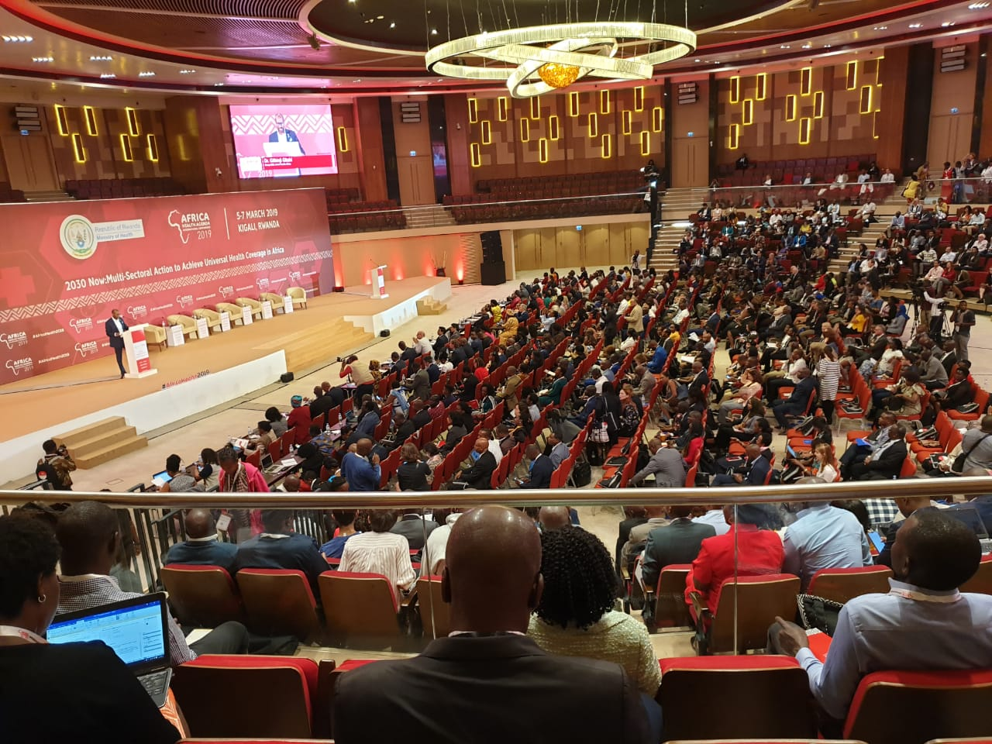
- About the NGO Finance Managers and Accountants Forum
It’s a peer learning and sharing platform of all professionals working with NGOs, International development agencies or externally funded projects as Finance Managers, Accountants, Auditors or Compliance Officers.

- Why the Forum?
In a rapidly changing dollar-biased world, those within the NGO financial industry are certainly facing more challenges than their peers in the private or corporate sector. While other finance officers focus on credit and debit, record keeping and other day-to-day transactional tasks, the NGO finance officer’s role in a modern world encompass far more responsibilities and skill-sets beyond these.

This forum addresses a critical capacity and learning gap because the finance office in the NGO has evolved to;

- Play diverse roles;
Beyond accounting issues, the NGO Finance Manager finds him/herself wearing various hats like additional management roles to ensure organizational objectives are met. In-fact it comes as no surprise that smaller CSOs which often lack a dedicated human resources officer, resign to their Accountant to double as their HR.

- Adopt new technology;
With the digital transformation in most sectors, NGO Finance Managers are experiencing a radical shift in how they perform their duties. An increasing focus on technology has seen finance move away from the traditional spreadsheet to automation solutions including cloud-based services. These digitized methods as a result require finance professionals to embrace financial analytics, tremendous visualization methods among others.

- Face new operational realities
In the wake of the Covid-19 pandemic, most CSOs are now dispersed, with employees working from home or across several different locations. Therefore, trials such as different time zones, poor internet connections, and relying on teleconferencing technology can hinder this communication. These fall in the docket and directly require finance managers or accountants to streamline.

- Streamline state regulations and dues
All sectors are subject to rules, regulations, and compliance, but perhaps none more so than the NGOs specifically those operating in regions where CSOs operations are highly controlled. A modern Finance officer and accountant is mandated to streamline the regulatory issues of the agency including paying taxes, registration fees, licenses and renewals.

- Enforce Program Compliance
Finance is the key to the success of any NGO hence the need to balance compliance demands. In order to do this successfully, finance managers are having to work longer hours, as well as outsource tasks, or hire extra staff to manage the additional work to keep on top of compliance.

- Lead in Resource Mobilization
As program officers develop technical areas of the proposals, the finance managers and accountants bear the bigger task of understanding, interpreting and working on the more complicated grant budgets.

- Ensure Reporting and providing real-time data
Data is a game changer for all areas of NGOs, particularly finance as it better enables key strategic initiatives and decisions, though it poses real-time challenges for NGOs. Along with dealing with poor data quality or inaccuracies, finance managers must also grapple with slow data production and the time-consuming nature of manual data ingestion.

- Manage Effective Communication
A Finance Manager is not only limited to working with fellow finance personnel but must also communicate and collaborate other departments and the external stakeholders. This responsibility comes with several trials and tribulations.

- The Goal of the Convention
These finance professionals are the heart-beat of these big NGOs, donor and multilateral agencies and over 300 of the members belong to this forum and plan to hold an Annual Convention which is a peer-driven capacity and learning forum to meet, learn, change and grow both in career and profession

- The Convention theme;
‘Improving financial management and compliance for NGOs in Uganda’

- The Convention Dates;
18th – 19th August, 2022

- Target Audience
Finance Managers and Officers, Project Accountants, Compliance Officers and Accounts Assistants

- The year 2022 Annual Convention Objectives
- Updates on new accounting, audit and compliance tools, methods and strategies
- Share and learn good finance and accounting practices and success stories among NGOs
- Information on new technologies concerning the finance and budget issues for NGOs
- Engage and streamline partnerships with statutory and government partners (Revenue Authority, Registrations Service Bureau, Donors, Audit and Compliance agencies)
- Provide refresher skills and knowledge for NGO finance professionals in modern financial management

- Conference Partnership Opportunities
The Forum welcomes partners that target NGOs specifically their Finance Managers and Officers. Any agency can join as a Conference Organizer, Sponsor, Presenter or a Conference Partner. Special focus is on statutory agencies, audit firms, private and corporate companies, Networks and Associations, Banks, Insurance partners, NGOs and International development bodies

- The 2022 Convention Agenda
Participants for the 2 day Convention in August 2022 will be by registration and invitation only. Over 700 Finance Managers, Accountants and Compliance Officers plus those working for public and local governments but on donor funded projects will attend. A detailed agenda will be issued to participants but will cover the following tracks;

Workshop Track 1: Financial Management and Accounting for NGOs
The focus is on practice-oriented approach to NGO accounting and finance. It aims at providing the necessary knowledge and skills for the professionals to cope with tasks that finance, accountants and budget managers of modern NGOs have to face.

Workshop Track 2: Fundraising and Sustainability Strategies
World over, there is a growing shift from reliance solely on donor funding to other internal income. The main question is; how do Non Profit Organizations (NPOs) adapt to this shift while retaining their core objective and what is the role of the Finance Manager/ Officer? This shift demands for a reshaping of the role of the finance office to lead the resource mobilization process.

Workshop Track 3: Mandatory Governance and Compliance issues
NGOs in Uganda have been faced with questions such as; which specific standards do they apply in their reporting? How do they marry their near-cash reporting to the accrual-based accounting called upon by government? How will the donor reports be aligned to the Financial Agencies compliant financial statements? What interest does the tax, registrations and compliance authorities have in NGOs? This session will focus on a finance office that is able to promote compliance and credibility

Workshop Track 4: New Technology and Innovations in Finance for NGOs
Covid19 and the need to sustainably manage the limited resources has driven grant recipients and finance managers to adopt more advanced technological approaches in conducting and managing NGO business. This will position the Finance Manager/ Officer to build a technology compliant and innovation focused agency
- How the NGO Finance Managers and Accountants Forum operates
The forum is presently hosted at LINK Partners International and is coordinated by an Administrator who supports the membership and capacity building activities. The overall activities are overseen by 3 elected members who serve a period of 2 years as the Association President, the Vice President and Treasurer.

You can;
- Join as an NGO Finance Managers and Accountants Forum member
- Receive the convention Agenda/ register to attend 2022 Convention
- Become a Forum partner

Contacts:
Mobile/Whattup: +256 756-049726
E-mail: csofams@gmail.com

